** git restore “<file_name>” :it will restore the older file

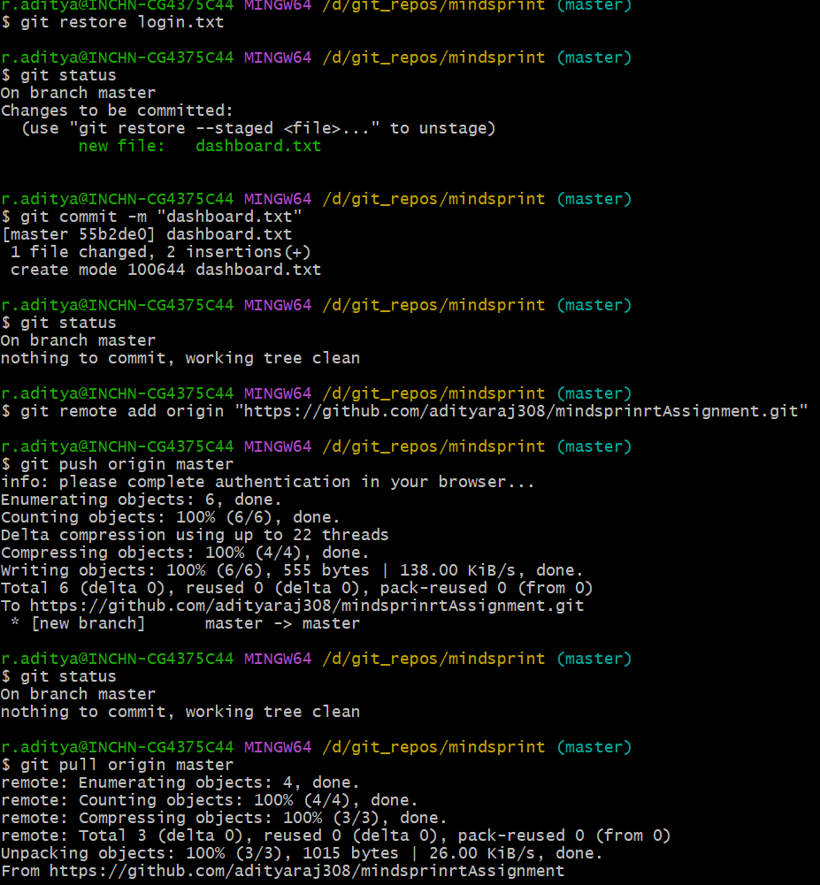

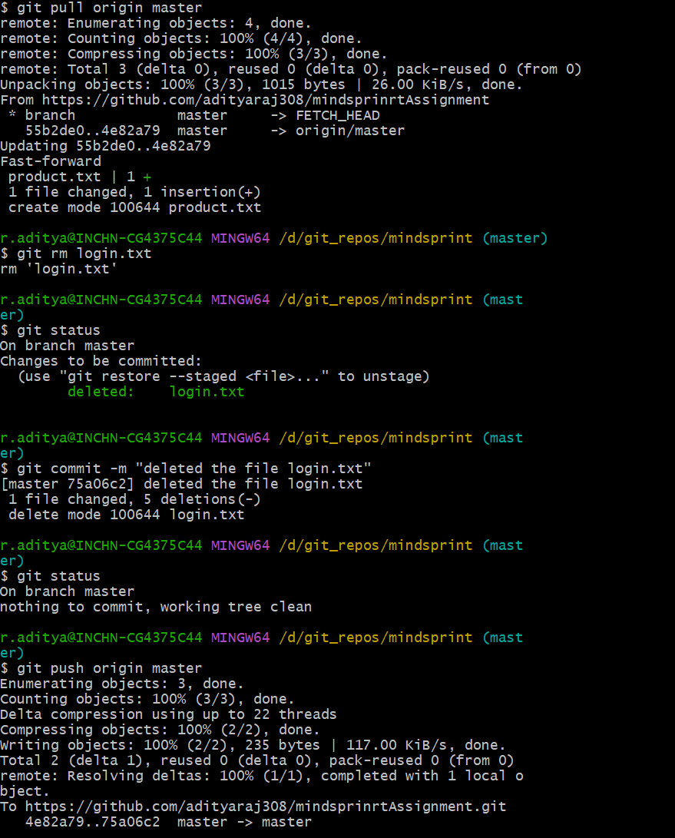

asdk

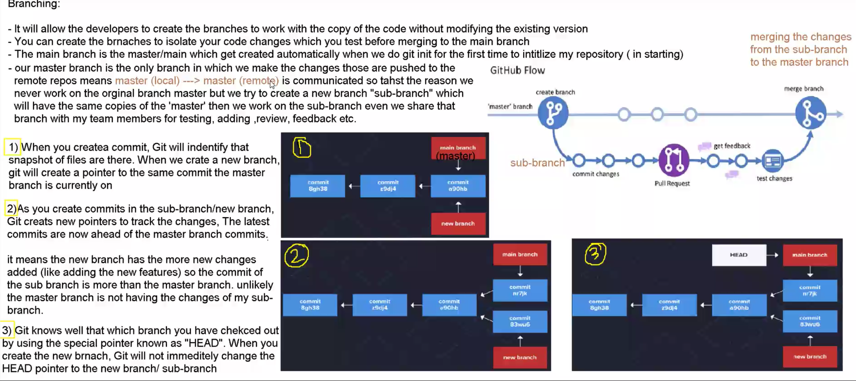

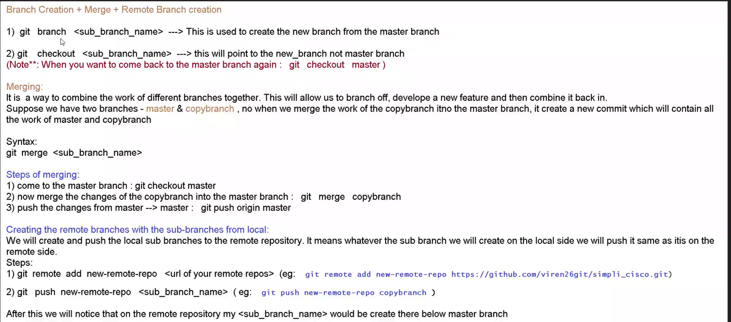

BRANHCING:



